1. Format all cells -> Autofit column width
2. No duplicate Id values found
3. Data validation – Gender – F or M only
4. Converting all the ZIP values to ZIP+4 format

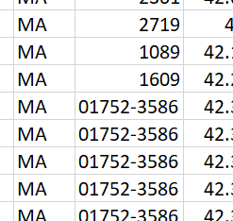 to 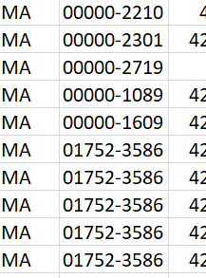

1. Ensure LAT and LONG have equal decimal points
2. Remove unwanted numbers in the NAME column

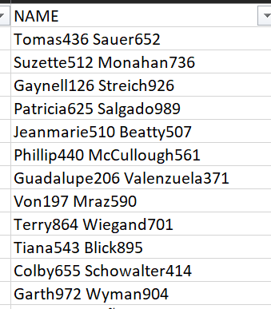 to 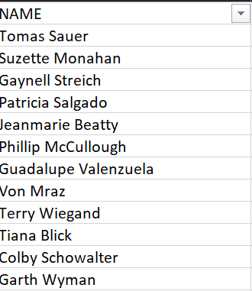

Open with Unicode to correctly see Latin letters

1. ADDRESS – Case not uniform, and unwanted spaces present – use trim(upper(

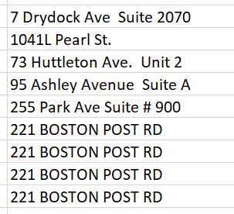 to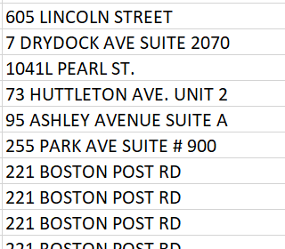

1. Same with CITY – use upper()

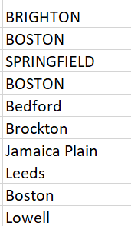 to 